**Anudip Foundation – AJP Lab 2**

Q1. Create a class called Student with the following attributes: Roll Number, Name, Department. Write a method to display student details. Create and display the details of three students using objects

**PROGRAM:**

import java.util.Scanner;

class Student {

    int rollNumber;

    String name;

    String department;

    // -------- constructor --------

    Student(int rollNumber, String name, String department) {

        this.rollNumber = rollNumber;

        this.name       = name;

        this.department = department;

    }

    // -------- method --------

    void displayDetails() {

        System.out.println("Roll Number : " + rollNumber);

        System.out.println("Name        : " + name);

        System.out.println("Department  : " + department);

        System.out.println("-----------------------");

    }

    public static void main(String[] args) {

        Scanner sc = new Scanner(System.in);

        Student[] students = new Student[3];

        for (int i = 0; i < 3; i++) {

            System.out.println("\nEnter details for Student " + (i + 1) + ":");

            System.out.print("Roll Number: ");

            int roll = sc.nextInt();

            sc.nextLine();

            System.out.print("Name: ");

            String name = sc.nextLine();

            System.out.print("Department: ");

            String dept = sc.nextLine();

            students[i] = new Student(roll, name, dept);

        }

        System.out.println("\nStudent Details");

        for (Student s : students) {

            s.displayDetails();

        }

        sc.close();

    }

}

**OUTPUT:**

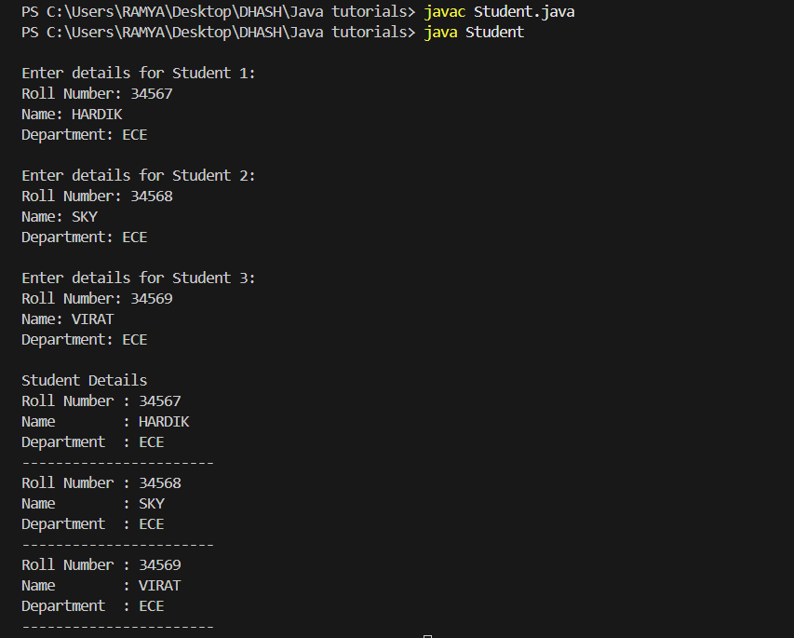

Q2. Create a class called BankAccount with the following: Account Number, Account Holder Name, Balance. Write methods to deposit, withdraw, and display balance. Create an object and perform all operations.

**PROGRAM:**

import java.util.Scanner;

class BankAccount {

    private int    accountNumber;

    private String accountHolderName;

    private double balance;

    // -------- constructor --------

    BankAccount(int accountNumber, String accountHolderName, double balance) {

        this.accountNumber     = accountNumber;

        this.accountHolderName = accountHolderName;

        this.balance           = balance;

    }

    // -------- behaviours --------

    void deposit(double amount) {

        balance += amount;

        System.out.println("Deposited $" + amount);

    }

    void withdraw(double amount) {

        if (amount <= balance) {

            balance -= amount;

            System.out.println("Withdrawn $" + amount);

        } else {

            System.out.println("Insufficient balance!");

        }

    }

    void displayBalance() {

        System.out.println("Account Number     : " + accountNumber);

        System.out.println("Account Holder Name: " + accountHolderName);

        System.out.println("Current Balance    : $" + balance);

    }

    public static void main(String[] args) {

        Scanner sc = new Scanner(System.in);

        System.out.print("Enter Account Number: ");

        int accNum = sc.nextInt(); sc.nextLine();

        System.out.print("Enter Account Holder Name: ");

        String holder = sc.nextLine();

        System.out.print("Enter Opening Balance: ");

        double bal = sc.nextDouble();

        BankAccount acc = new BankAccount(accNum, holder, bal);

        int choice;

        do {

            System.out.println("\n1. Deposit\n2. Withdraw\n3. Display Balance\n4. Exit");

            System.out.print("Choose an option: ");

            choice = sc.nextInt();

            switch (choice) {

                case 1:

                    System.out.print("Enter amount to deposit: ");

                    acc.deposit(sc.nextDouble());

                    break;

                case 2:

                    System.out.print("Enter amount to withdraw: ");

                    acc.withdraw(sc.nextDouble());

                    break;

                case 3:

                    acc.displayBalance();

                    break;

                case 4:

                    System.out.println("Thank you!");

                    break;

                default:

                    System.out.println("Invalid choice!");

            }

        } while (choice != 4);

        sc.close();

    }

}

**OUTPUT:**

